**Building A Restaurant Website With Bootstrap.**

DESCRIPTION

**Project objective:**

Build a responsive website for a restaurant where users can read the details of the restaurant.’

**Background of the problem statement:**

You are a web developer at a service-based web development company called Kite Technologies. The company has been approached by a client who wants to build a website for their restaurant named Ming’s Diner. The website should provide the users a brief overview of the restaurant and its bestsellers, its address, as well as an option to contact the restaurant. During sprint planning, you agree to lead this project and develop the website.

Building a navbar using Bootstrap in your code editor

Open Visual Studio Code and create a new file to type the code in.

Right click on the **File menu** of the code editor -> Select New File

**Create index.html**

<html>

<head>

<title>YuvaRaj Restaurant</title>

<meta *name*="viewport" *content*="width=device-width,initial-scale=1.0,user-scalable=yes">

<link *rel*="stylesheet" *type*="text/css" *href*="css/bootstrap.min.css" />

<link *rel*="stylesheet" *type*="text/css" *href*="css/style.css" />

<link *rel*="stylesheet" *type*="text/css" *href*="css/font-awesome.min.css" />

</head>

<body>

<div *class*="container-fluid">

<div *class*="main">

*<!-- Start Header -->*

<div *class*="row header">

    <div *class*="col-md-3 col-sm-3 col-xs-12 logo" align="center">

    </div>

    <div *class*="col-md-9 col-sm-9 col-xs-12">

        <nav *class*="navbar navbar-default header-right pull-right">

            <div *class*="navbar-header">

            <button *type*="button" *data-target*="#navbarCollapse" *data-toggle*="collapse" *class*="navbar-toggle">

                <span *class*="sr-only">Toggle navigation</span>

                <span *class*="icon-bar"></span>

                <span *class*="icon-bar"></span>

                <span *class*="icon-bar"></span>

            </button>

*<!--<a href="#" class="navbar-brand">Free Time Learning</a>-->*

            </div>

            <div *id*="navbarCollapse" *class*="collapse navbar-collapse">

            <ul *class*="nav navbar-nav">

                <li><a *href*="#!">Home</a></li>

                <li><a *href*="#!">About</a></li>

                <li><a *href*="#!">Today Special</a></li>

                <li><a *href*="#!">Menu Card</a></li>

                <li><a *href*="#!">Reservation</a></li>

                <li><a *href*="#!">Review</a></li>

                <li><a *href*="#!">Contact</a></li>

            </ul>

            </div>

        </nav>

   </div>

   <div *class*="clearfix"></div>

   <div *class*="header-bottom">

        <div *class*="header-font">Eat healthy food &amp; Enjoy your life.</div>

        <div *class*="p50_0" align="center">

        <a *href*="#!" *class*="header-btns">BOOK A TABLE</a>&nbsp; &nbsp; &nbsp; &nbsp;

        <a *href*="#!" *class*="header-btns">SEE THE MENU </a>

        </div>

    </div>

</div>

*<!-- End Header -->*

*<!----- Start Content Part 1 ------>*

<div *class*="row">

    <div *class*="col-md-5 col-sm-6 col-xs-12">

        <div *class*="content-part-1-left-h3">Lorem Ipsum is simply dummy text...</div>

        <div *class*="content-part-1-left-p">

        Lorem Ipsum is simply dummy text of the printing and typesetting industry. Lorem Ipsum has been the

        industry's standard dummy text ever since the 1500s, when an unknown printer took a galley of type

        and scrambled it to make a type specimen book. It has survived not only five centuries, but also the

        leap into electronic typesetting, remaining essentially unchanged.

        </div>

        <div *class*="p20_0"><a *href*="#!" *class*="content-part-1-left-btn">Read More.</a></div>

    </div>

    <div *class*="col-md-7 col-sm-6 col-xs-12" align="center">

        <div *class*="content-part-1-right">

            <img *src*="images/content-part-1.jpg" *class*="img-responsive" *alt*="Restaurant">

        </div>

    </div>

</div>

*<!----- End Content Part 1 ------>*

*<!----- Start Content Part 2 ------>*

<div *class*="row">

    <div *class*="content-part-2">

        <div *class*="content-part-2-inner">

            <div *class*="interior-font">Restaurant Interior</div>

            <div *class*="col-md-6 col-sm-6 col-xs-12">

                <div *class*="content-interior">

                    <img *src*="images/interior.jpg" *class*="img-responsive" *alt*="Restaurant" />

                    <div *class*="content-interior-h3">Non AC Hall</div>

                    <div *class*="content-interior-p">Lorem Ipsum is simply dummy text of the printing and typesetting industry.

                    Lorem Ipsum has been the industry's standard dummy text ever since the 1500s.</div>

                </div>

            </div>

            <div *class*="col-md-6 col-sm-6 col-xs-12">

                <div *class*="content-interior">

                    <img *src*="images/interior-2.jpg" *class*="img-responsive" *alt*="Restaurant" />

                    <div *class*="content-interior-h3">Central AC Hall</div>

                    <div *class*="content-interior-p">Lorem Ipsum is simply dummy text of the printing and typesetting industry.

                    Lorem Ipsum has been the industry's standard dummy text ever since the 1500s.</div>

                </div>

            </div>

        </div>

    </div>

</div>

*<!----- End Content Part 2 ------>*

*<!----- Start Content Part 3 ------>*

<div *class*="row">

    <div *class*="content-part-3">

        <div *class*="col-md-6 col-sm-12 col-xs-12">

            <div *class*="row content-part-3-inner">

                <div *class*="col-md-5 col-sm-5 col-xs-12" align="center">

                    <img *src*="images/menu/1.jpg" *class*="img-responsive img" *alt*="Menu Item">

                </div>

                <div *class*="col-md-7 col-sm-7 col-xs-12">

                    <div *class*="content-part-3-right-h4">Lorem Ipsum</div>

                    <div *class*="price">Price : <i *class*="green"><span *class*="fa fa-inr"></span>55.00/-</i></div>

                    Lorem Ipsum is simply dummy text of the printing and typesetting industry.

                    <div *class*="margin_p3"><a *href*="#!" *class*="order-now">Order Now</a></div>

                </div>

            </div>

        </div>

        <div *class*="col-md-6 col-sm-12 col-xs-12">

            <div *class*="row content-part-3-inner">

                <div *class*="col-md-5 col-sm-5 col-xs-12" align="center">

                    <img *src*="images/menu/2.jpg" *class*="img-responsive img" *alt*="Menu Item">

                </div>

                <div *class*="col-md-7 col-sm-7 col-xs-12">

                    <div *class*="content-part-3-right-h4">Lorem Ipsum</div>

                    <div *class*="price">Price : <i *class*="green"><span *class*="fa fa-inr"></span>150.00/-</i></div>

                    Lorem Ipsum is simply dummy text of the printing and typesetting industry.

                    <div *class*="margin_p3"><a *href*="#!" *class*="order-now">Order Now</a></div>

                </div>

            </div>

        </div>

        <div *class*="col-md-6 col-sm-12 col-xs-12">

            <div *class*="row content-part-3-inner">

                <div *class*="col-md-5 col-sm-5 col-xs-12" align="center">

                    <img *src*="images/menu/3.jpg" *class*="img-responsive img" *alt*="Menu Item">

                </div>

                <div *class*="col-md-7 col-sm-7 col-xs-12">

                    <div *class*="content-part-3-right-h4">Lorem Ipsum</div>

                    <div *class*="price">Price : <i *class*="green"><span *class*="fa fa-inr"></span>220.00/-</i></div>

                    Lorem Ipsum is simply dummy text of the printing and typesetting industry.

                    <div *class*="margin_p3"><a *href*="#!" *class*="order-now">Order Now</a></div>

                </div>

            </div>

        </div>

        <div *class*="col-md-6 col-sm-12 col-xs-12">

            <div *class*="row content-part-3-inner">

                <div *class*="col-md-5 col-sm-5 col-xs-12" align="center">

                    <img *src*="images/menu/4.jpg" *class*="img-responsive img" *alt*="Menu Item">

                </div>

                <div *class*="col-md-7 col-sm-7 col-xs-12">

                    <div *class*="content-part-3-right-h4">Lorem Ipsum</div>

                    <div *class*="price">Price : <i *class*="green"><span *class*="fa fa-inr"></span>90.00/-</i></div>

                    Lorem Ipsum is simply dummy text of the printing and typesetting industry.

                    <div *class*="margin_p3"><a *href*="#!" *class*="order-now">Order Now</a></div>

                </div>

            </div>

        </div>

        <div *class*="col-md-6 col-sm-12 col-xs-12">

            <div *class*="row content-part-3-inner">

                <div *class*="col-md-5 col-sm-5 col-xs-12" align="center">

                    <img *src*="images/menu/5.jpg" *class*="img-responsive img" *alt*="Menu Item">

                </div>

                <div *class*="col-md-7 col-sm-7 col-xs-12">

                    <div *class*="content-part-3-right-h4">Lorem Ipsum</div>

                    <div *class*="price">Price : <i *class*="green"><span *class*="fa fa-inr"></span>250.00/-</i></div>

                    Lorem Ipsum is simply dummy text of the printing and typesetting industry.

                    <div *class*="margin_p3"><a *href*="#!" *class*="order-now">Order Now</a></div>

                </div>

            </div>

        </div>

        <div *class*="col-md-6 col-sm-12 col-xs-12">

            <div *class*="row content-part-3-inner">

                <div *class*="col-md-5 col-sm-5 col-xs-12" align="center">

                    <img *src*="images/menu/6.jpg" *class*="img-responsive img" *alt*="Menu Item">

                </div>

                <div *class*="col-md-7 col-sm-7 col-xs-12">

                    <div *class*="content-part-3-right-h4">Lorem Ipsum</div>

                    <div *class*="price">Price : <i *class*="green"><span *class*="fa fa-inr"></span>300.00/-</i></div>

                    Lorem Ipsum is simply dummy text of the printing and typesetting industry.

                    <div *class*="margin_p3"><a *href*="#!" *class*="order-now">Order Now</a></div>

                </div>

            </div>

        </div>

        <div *class*="col-md-6 col-sm-12 col-xs-12">

            <div *class*="row content-part-3-inner">

                <div *class*="col-md-5 col-sm-5 col-xs-12" align="center">

                    <img *src*="images/menu/7.jpg" *class*="img-responsive img" *alt*="Menu Item">

                </div>

                <div *class*="col-md-7 col-sm-7 col-xs-12">

                    <div *class*="content-part-3-right-h4">Lorem Ipsum</div>

                    <div *class*="price">Price : <i *class*="green"><span *class*="fa fa-inr"></span>270.00/-</i></div>

                    Lorem Ipsum is simply dummy text of the printing and typesetting industry.

                    <div *class*="margin_p3"><a *href*="#!" *class*="order-now">Order Now</a></div>

                </div>

            </div>

        </div>

        <div *class*="col-md-6 col-sm-12 col-xs-12">

            <div *class*="row content-part-3-inner">

                <div *class*="col-md-5 col-sm-5 col-xs-12" align="center">

                    <img *src*="images/menu/8.jpg" *class*="img-responsive img" *alt*="Menu Item">

                </div>

                <div *class*="col-md-7 col-sm-7 col-xs-12">

                    <div *class*="content-part-3-right-h4">Lorem Ipsum</div>

                    <div *class*="price">Price : <i *class*="green"><span *class*="fa fa-inr"></span>325.00/-</i></div>

                    Lorem Ipsum is simply dummy text of the printing and typesetting industry.

                    <div *class*="margin_p3"><a *href*="#!" *class*="order-now">Order Now</a></div>

                </div>

            </div>

        </div>

        <div *class*="col-md-6 col-sm-12 col-xs-12">

            <div *class*="row content-part-3-inner">

                <div *class*="col-md-5 col-sm-5 col-xs-12" align="center">

                    <img *src*="images/menu/9.jpg" *class*="img-responsive img" *alt*="Menu Item">

                </div>

                <div *class*="col-md-7 col-sm-7 col-xs-12">

                    <div *class*="content-part-3-right-h4">Lorem Ipsum</div>

                    <div *class*="price">Price : <i *class*="green"><span *class*="fa fa-inr"></span>455.00/-</i></div>

                    Lorem Ipsum is simply dummy text of the printing and typesetting industry.

                    <div *class*="margin_p3"><a *href*="#!" *class*="order-now">Order Now</a></div>

                </div>

            </div>

        </div>

        <div *class*="col-md-6 col-sm-12 col-xs-12">

            <div *class*="row content-part-3-inner">

                <div *class*="col-md-5 col-sm-5 col-xs-12" align="center">

                    <img *src*="images/menu/10.jpg" *class*="img-responsive img" *alt*="Menu Item">

                </div>

                <div *class*="col-md-7 col-sm-7 col-xs-12">

                    <div *class*="content-part-3-right-h4">Lorem Ipsum</div>

                    <div *class*="price">Price : <i *class*="green"><span *class*="fa fa-inr"></span>180.00/-</i></div>

                    Lorem Ipsum is simply dummy text of the printing and typesetting industry.

                    <div *class*="margin_p3"><a *href*="#!" *class*="order-now">Order Now</a></div>

                </div>

            </div>

        </div>

        <div *class*="col-md-6 col-sm-12 col-xs-12">

            <div *class*="row content-part-3-inner">

                <div *class*="col-md-5 col-sm-5 col-xs-12" align="center">

                    <img *src*="images/menu/11.jpg" *class*="img-responsive img" *alt*="Menu Item">

                </div>

                <div *class*="col-md-7 col-sm-7 col-xs-12">

                    <div *class*="content-part-3-right-h4">Lorem Ipsum</div>

                    <div *class*="price">Price : <i *class*="green"><span *class*="fa fa-inr"></span>200.00/-</i></div>

                    Lorem Ipsum is simply dummy text of the printing and typesetting industry.

                    <div *class*="margin_p3"><a *href*="#!" *class*="order-now">Order Now</a></div>

                </div>

            </div>

        </div>

        <div *class*="col-md-6 col-sm-12 col-xs-12">

            <div *class*="row content-part-3-inner">

                <div *class*="col-md-5 col-sm-5 col-xs-12" align="center">

                    <img *src*="images/menu/12.jpg" *class*="img-responsive img" *alt*="Menu Item">

                </div>

                <div *class*="col-md-7 col-sm-7 col-xs-12">

                    <div *class*="content-part-3-right-h4">Lorem Ipsum</div>

                    <div *class*="price">Price : <i *class*="green"><span *class*="fa fa-inr"></span>155.00/-</i></div>

                    Lorem Ipsum is simply dummy text of the printing and typesetting industry.

                    <div *class*="margin_p3"><a *href*="#!" *class*="order-now">Order Now</a></div>

                </div>

            </div>

        </div>

        <div *class*="col-md-6 col-sm-12 col-xs-12">

            <div *class*="row content-part-3-inner">

                <div *class*="col-md-5 col-sm-5 col-xs-12" align="center">

                    <img *src*="images/menu/13.jpg" *class*="img-responsive img" *alt*="Menu Item">

                </div>

                <div *class*="col-md-7 col-sm-7 col-xs-12">

                    <div *class*="content-part-3-right-h4">Lorem Ipsum</div>

                    <div *class*="price">Price : <i *class*="green"><span *class*="fa fa-inr"></span>499.00/-</i></div>

                    Lorem Ipsum is simply dummy text of the printing and typesetting industry.

                    <div *class*="margin_p3"><a *href*="#!" *class*="order-now">Order Now</a></div>

                </div>

            </div>

        </div>

        <div *class*="col-md-6 col-sm-12 col-xs-12">

            <div *class*="row content-part-3-inner">

                <div *class*="col-md-5 col-sm-5 col-xs-12" align="center">

                    <img *src*="images/menu/14.jpg" *class*="img-responsive img" *alt*="Menu Item">

                </div>

                <div *class*="col-md-7 col-sm-7 col-xs-12">

                    <div *class*="content-part-3-right-h4">Lorem Ipsum</div>

                    <div *class*="price">Price : <i *class*="green"><span *class*="fa fa-inr"></span>99.00/-</i></div>

                    Lorem Ipsum is simply dummy text of the printing and typesetting industry.

                    <div *class*="margin_p3"><a *href*="#!" *class*="order-now">Order Now</a></div>

                </div>

            </div>

        </div>

    </div>

</div>

*<!----- End Content Part 3 ------>*

*<!----- Start Footer ------>*

<div *class*="row footer">

    <div *class*="col-md-4 col-sm-4 col-xs-12">

        <div *class*="footer-parts-h3">About Restaurant</div>

        <div *class*="footer-parts-p">

        Lorem Ipsum is simply dummy text of the printing and typesetting industry. Lorem Ipsum has been the industry's

        standard dummy text ever since the 1500s, when an unknown printer took a galley of type and scrambled it to

        make a type specimen book.</div>

    </div>

    <div *class*="col-md-1 col-sm-1"></div>

    <div *class*="col-md-3 col-sm-3 col-xs-12">

        <div *class*="footer-parts-h3">Opening Hours</div>

        <div *class*="footer-parts-p">

            Mon - Thu : 7:00 AM - 10:00 PM <br />

            Friday : 7:00 AM - 11:00 PM <br />

            Sat - Sun : 7:00 AM - 11:45 PM

        </div>

    </div>

    <div *class*="col-md-4 col-sm-4 col-xs-12">

        <div *class*="footer-parts-h3">Our Location</div>

        <div *class*="footer-parts-p">

            Mangamuru Road,Opp sirikala,<br />

            Andhra Pradesh, Prakasam(Dt), Ongole, India - 523002

        </div>

        <div *class*="footer-icons">

            <ul>

                <li><a *href*="#!"><i *class*="fa fa-facebook"></i></a></li>

                <li><a *href*="#!"><i *class*="fa fa-twitter"></i></a></li>

                <li><a *href*="#!"><i *class*="fa fa-linkedin"></i></a></li>

                <li><a *href*="#!"><i *class*="fa fa-google-plus"></i></a></li>

            </ul>

        </div>

    </div>

</div>

<div *class*="clearfix"></div>

<div *class*="row">

    <div *class*="footer-bottom">

        <div *class*="white">&copy; <script *language*="javascript" *type*="text/javascript">document.write(new Date().getFullYear());</script>.</div>

    </div>

</div>

*<!----- End Footer------>*

</div>

</div>

<script *type*="text/javascript" *src*="js/bootstrap.min.js"></script>

</body>

</html>

**Create a folder css and add**

**Create style.css**

@charset "utf-8"; */****   Developed by http://www.freetimelearning.com/    *****/*

*/* CSS Document */*

*/* (#) means ID Based */*

*/* (.) means class Based */*

*{

  margin-left:auto;

  margin-right:auto;

}

.row{ margin:0px;}

body{ font-family:Arial, Helvetica, sans-serif; margin:0px auto !important;}

.main{ margin:0px auto;

  -webkit-box-shadow: 0 6px 10px 0 rgba(0, 0, 0, 0.14), 0 1px 18px 0 rgba(0, 0, 0, 0.12), 0 3px 5px -1px rgba(0, 0, 0, 0.3) !important;

  box-shadow: 0 6px 10px 0 rgba(0, 0, 0, 0.14), 0 1px 18px 0 rgba(0, 0, 0, 0.12), 0 3px 5px -1px rgba(0, 0, 0, 0.3) !important;

}

.p10_0{ padding:10px 0px;} .p20_0{ padding:20px 0px;}.p30_0{ padding:30px 0px;}

.p40_0{ padding:40px 0px;} .p50_0{ padding:50px 0px;}

.clearfix{ clear:both;}

*/********* Start Header ***********/*

.header{ padding:10px 0px; background:url(../images/home-bg.jpg); height:500px; background-attachment:fixed;}

.header-left{padding:15px 20px;}

.header-right{padding-top:50px;}

.white{ color:#FFF; text-decoration:none;}

.white a{ color:#FFF; text-decoration:none;}

.white a:hover{ color:#CCC;}

.header-bottom{ padding:75px 0px 20px;}

.header-font{ color:#FFF; text-align:center; font-size:48px; text-transform:uppercase; font-weight:bold; padding:0px;}

.header-btns{ color:#FFF; font-size:16px; font-weight:500; border:1px solid #FFF;

padding:10px 30px; text-decoration:none; border-radius:2px;}

.header-btns:hover{ background:#7db549; color:#FFF; border:1px solid #7db549; text-decoration:none;}

.navbar-brand {

    float: left;

    height: 65px;

    padding: 5px 15px;

    font-size: 18px;

    line-height: 20px;

}

.navbar-default{

  border-radius:2px;

  background:none;

  margin-bottom:0px;

  border:none !important;

}

.navbar-default ul{ padding:9px 0px 5px;}

.navbar-default .navbar-nav>li>a{

  color:#FFF;

  padding:6px 22px;

  font-size:14px;

  margin:5px 14px 0px;

  border:1px solid #FFF; border-radius:2px;

}

.navbar-default .navbar-nav>li>a:hover{background:#7db549 !important; color:#FFF;}

.navbar-default .navbar-collapse, .navbar-default .navbar-form{

    border-color: #e7e7e7;

}

.navbar-default .navbar-nav>.open>a, .navbar-default .navbar-nav>.open>a:focus, .navbar-default .navbar-nav>.open>a:hover{

  border:1px solid #7db549;

  }

.navbar-toggle{ margin-top:-20px;}

@media only screen and (min-width:320px) and (max-width:480px){

.logo{ padding:10px 0px 0px;}

.header-right{padding-top:0px;}

.header-font{font-size:28px;}

.header-btns{ padding:6px 10px;}

}

@media only screen and (min-width:600px) and (max-width:768px){

.header{ padding:10px 0px; height:350px;}

.navbar-default .navbar-nav>li>a{padding:7px 6px; font-size:11px; margin:5px 5px 0px;}

.header-right{padding-top:15px;}

.header-font{font-size:28px;}

.header-btns{ padding:8px 20px;}

}

@media only screen and (min-width:1025px) and (max-width:1280px){

  .navbar-default .navbar-nav>li>a{padding:7px 15px; font-size:11px; margin:5px 10px 0px;}

  .header-right{padding-top:45px;}

   }

@media only screen and (min-width:960px) and (max-width:1024px){

  .header{ padding:10px 0px; height:400px;}

  .navbar-default .navbar-nav>li>a{padding:7px 15px; font-size:11px; margin:5px 10px 0px;}

  .header-font{font-size:34px;}

  .header-right{padding-top:35px;}

   }

*/*********** End Header **********/*

*/****** Start Content Part 1 **********/*

.content-part-1-left-h3{ font-size:28px; color:#7db549; font-weight:500; padding-top:120px; padding-left:10px;}

.content-part-1-left-p{font-size:14px; text-align:justify; color:#000; font-weight:500; line-height:26px; padding:10px 12px;}

.content-part-1-left-btn{ font-size:16px; font-weight:500; border:1px solid #7db549; color:#FFF;

padding:10px 30px; text-decoration:none; border-radius:2px; background:#7db549; margin:0px 10px;}

.content-part-1-left-btn:hover{ background:#689242;}

.content-part-1-right{ padding-top:10px;}

@media only screen and (min-width:320px) and (max-width:480px){

  .content-part-1-left-h3{ padding-top:30px; font-size:20px; text-align:center; }

  }

@media only screen and (min-width:600px) and (max-width:768px){

  .content-part-1-left-h3{ padding-top:20px; font-size:24px;}

  .content-part-1-right{ padding-top:80px;}

  }

*/****** End Content Part 1 **********/*

*/****** Start Content Part 2 *****/*

.content-part-2{ padding:10px 0px; background:url(../images/content-bg.jpg) no-repeat; height:600px; background-position:center  bottom; background-attachment:fixed;}

.interior-font{ font-size:36px; text-transform:uppercase; padding:20px 0px 30px; font-weight:600;

text-align:center; color:#000; text-shadow: 2px 2px 3px #333;}

.content-part-2-inner{background-color: rgba(255,255,255,.5); padding:20px 0px 20px; margin:50px 150px; float:left;

border-radius:3px;}

.content-interior{ padding:10px 25px; float:left;}

.content-interior-h3{ color:#000; font-size:18px; text-shadow: 2px 2px 3px #333; padding:10px 0px; text-align:center;}

.content-interior-p{ color:#000; padding:5px 0px 10px; font-size:14px; line-height:26px; text-align:justify;}

@media only screen and (min-width:320px) and (max-width:480px){

  .content-part-2{ padding:10px 0px; height:1000px;}

  .content-part-2-inner{padding:20px 0px; margin:50px 20px;}

  }

@media only screen and (min-width:600px) and (max-width:768px){

  .content-part-2-inner{padding:20px 0px; margin:50px 50px;}

  }

*/****** End Content Part 2 ********/*

*/****** Start Content Part 3 ********/*

.img{ width:90%; height:auto;}

.content-part-3{ padding:30px 0px !important; float:left;}

.content-part-3-inner{ padding:10px 0px;}

.content-part-3-right-h4{ font-weight:600; color:#000; padding:0px;}

.margin_5{ margin:5px 0px; float:left;}

.margin_p3{ margin:10px 0px 5px;}

.price{color:#000; padding:5px 0px; font-weight:bold; font-size:15px;}

.green{ color:#7db549; font-weight:bold; font-size:16px;}

.order-now{ color:#FFF; background:#7db549; padding:5px 15px; border-radius:2px; text-decoration:none; margin:5px auto;}

.order-now:hover{background:#689242;}

@media only screen and (min-width:320px) and (max-width:480px){

  .img{ width:100%;}

  }

@media only screen and (min-width:600px) and (max-width:768px){

  .img{ width:96%; border-radius:3px;}

  .content-part-3-right-h4{ font-weight:600; color:#000; padding:5px 0px 0px;}

  }

*/****** End Content Part 3 ********/*

*/****** Start Footer ********/*

.footer{padding:20px 0px; background:#333;}

.footer-parts-h3{ font-size:18px; font-weight:600; color:#FFF; padding:10px 0px;}

.footer-parts-p{ color:#000; line-height:24px; text-align:justify; color:#FFF;}

.footer-icons{list-style:none;}

.footer-icons ul{list-style:none; padding:0px;}

.footer-icons ul li{float:left; padding:0px 25px 0px 5px; text-transform:uppercase;}

.footer-icons ul li a{color:#FFF; font-weight:600; font-size:18px;}

.footer-icons ul li a:hover{ color:#CCC;}

.footer-bottom{padding:15px; text-align:center; color:#FFF; font-size:13px; background:#000;}

*/****** End Footer ********/*

**Create another folder name it as images:**

**In that create another folder Menu:**

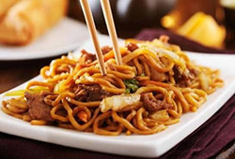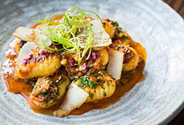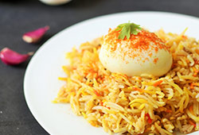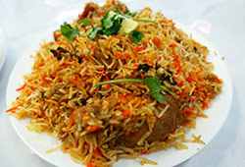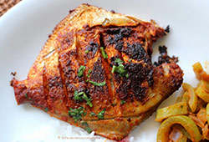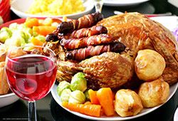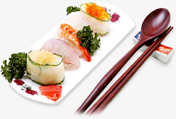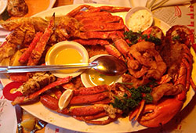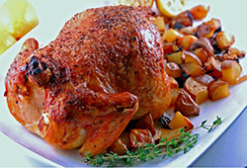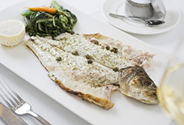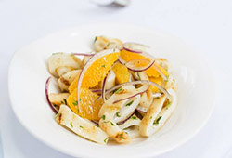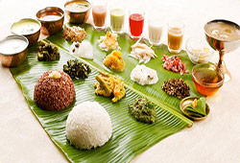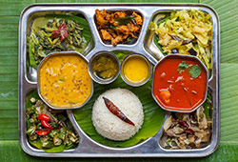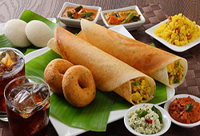

**In that images folder add some more images**

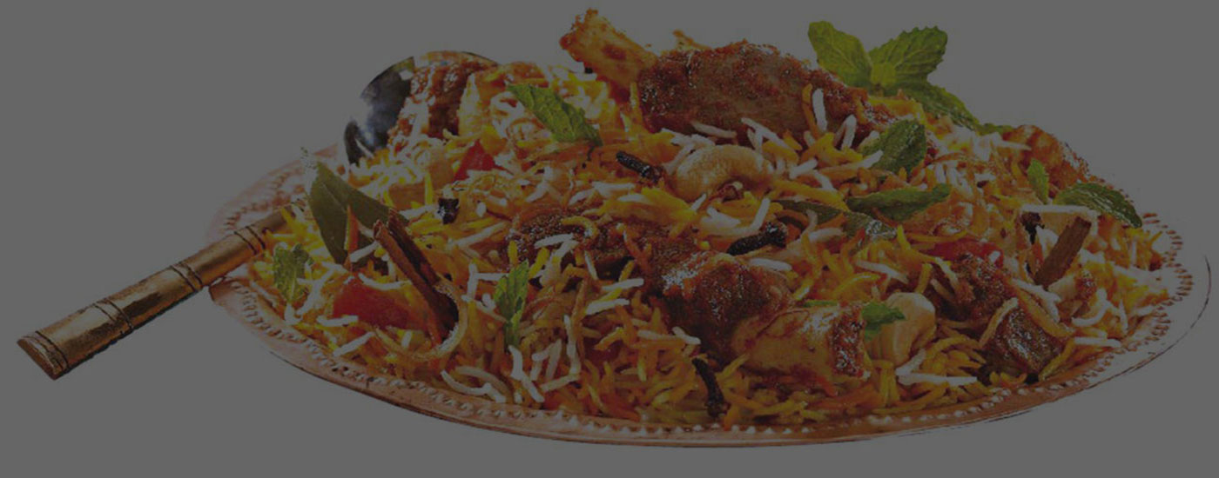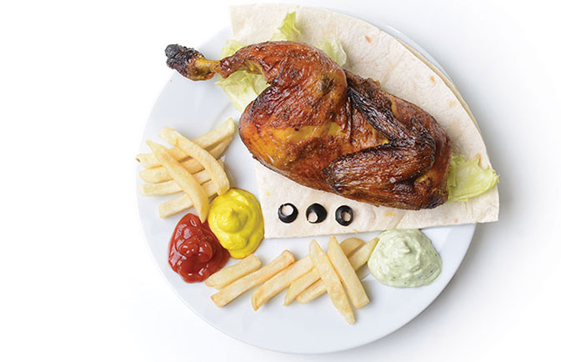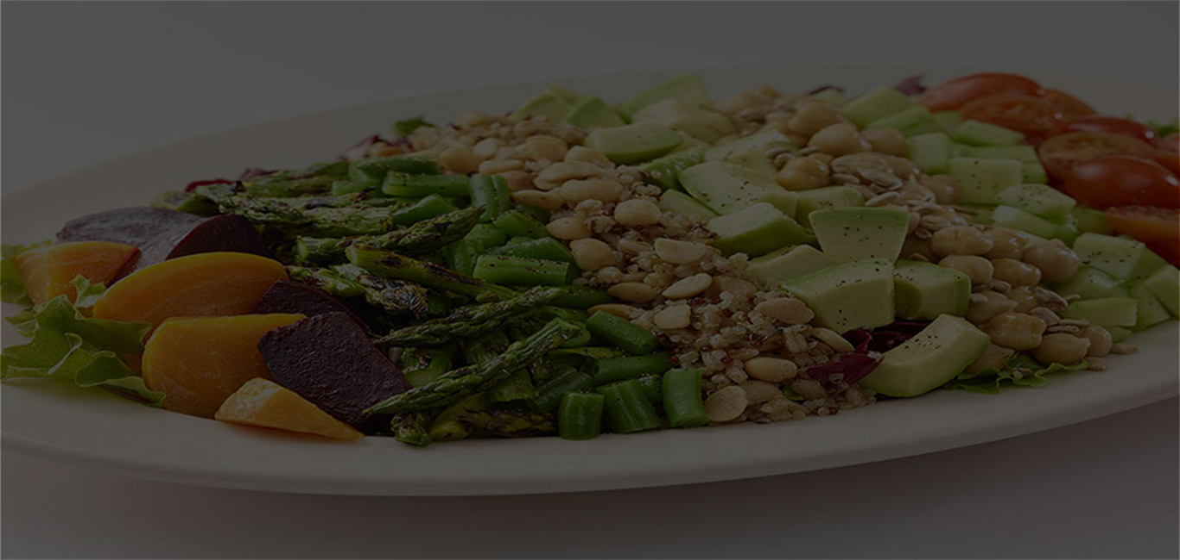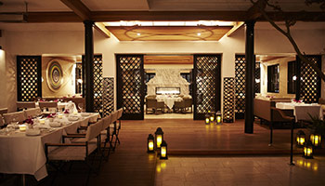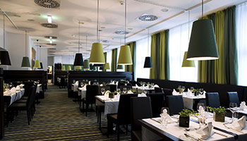

**To Run the project Right click on index.html open with live server.**

**(Or)**

**http://127.0.0.1:5500/**

**Pushing the code to your GitHub repositories**

* Open your command prompt and navigate to the folder where you have created your files.

**cd <folder path>**

* Initialize your repository using the following command:

**git init**

* Add all the files to your git repository using the following command:

**git add .**

* Commit the changes using the following command:

**git commit . -m “Changes have been committed.”**

* Push the files to the folder you initially created using the following command:

**git push -u origin master**